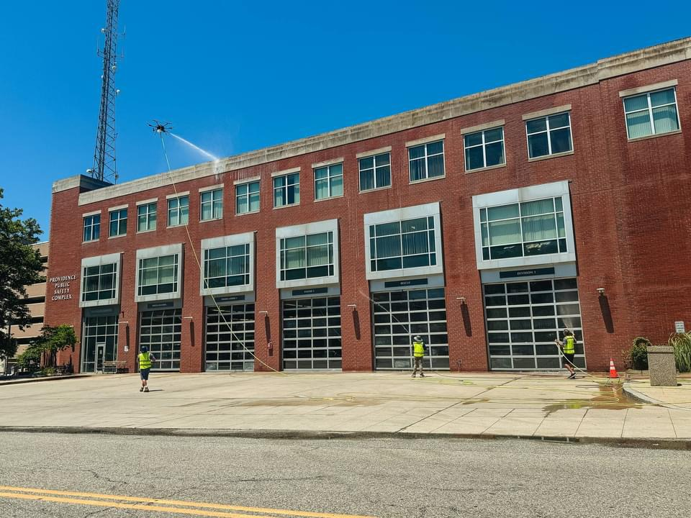
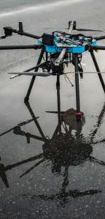
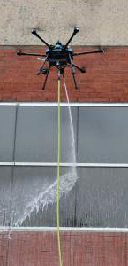
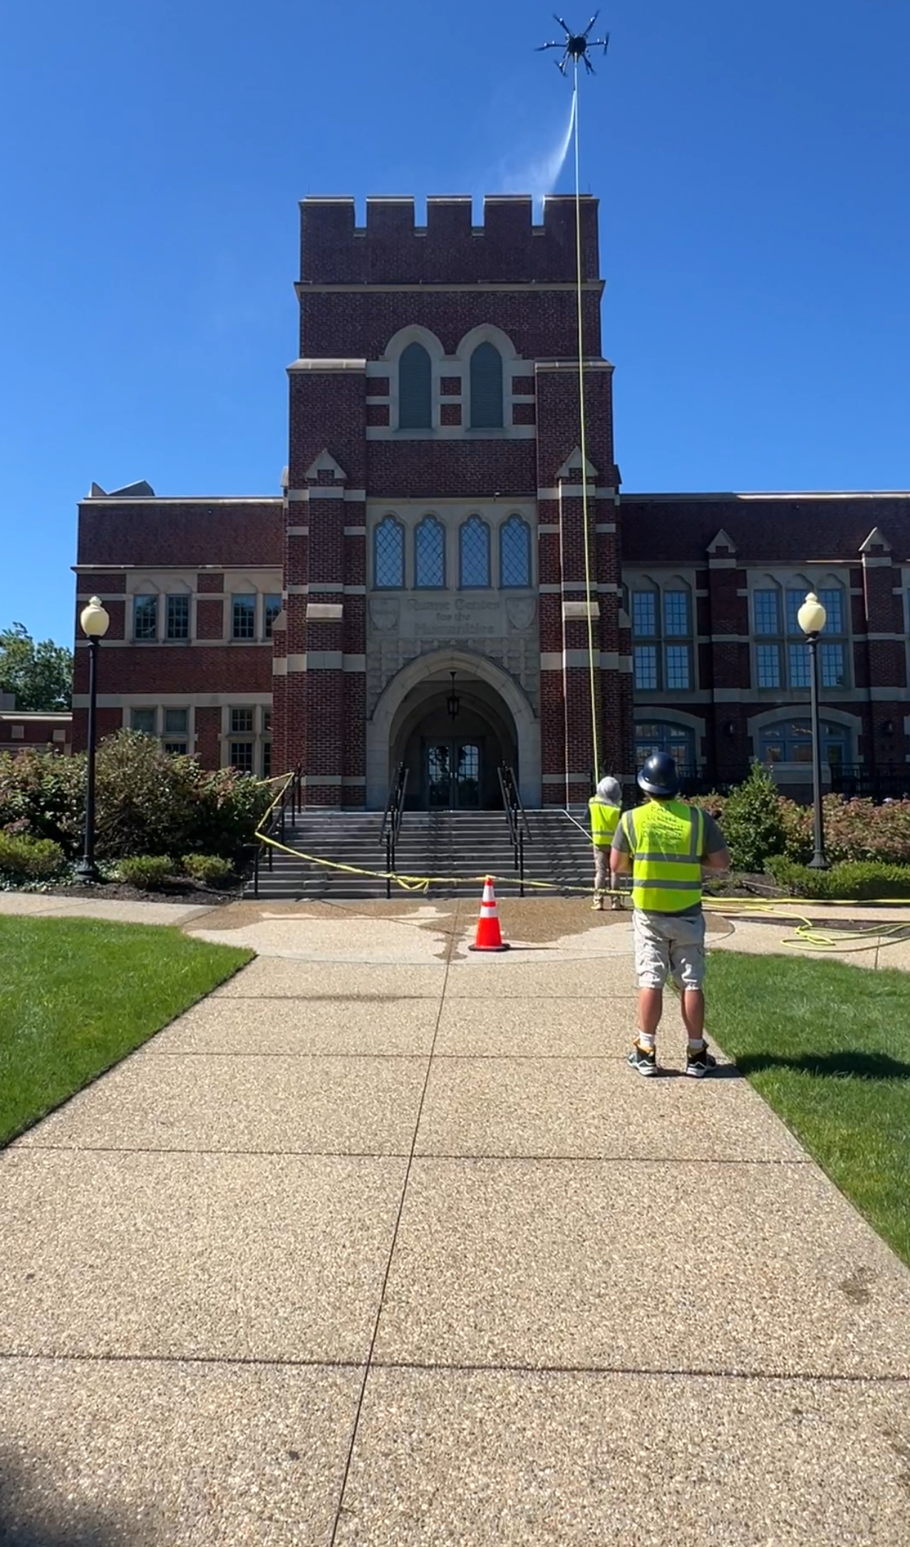
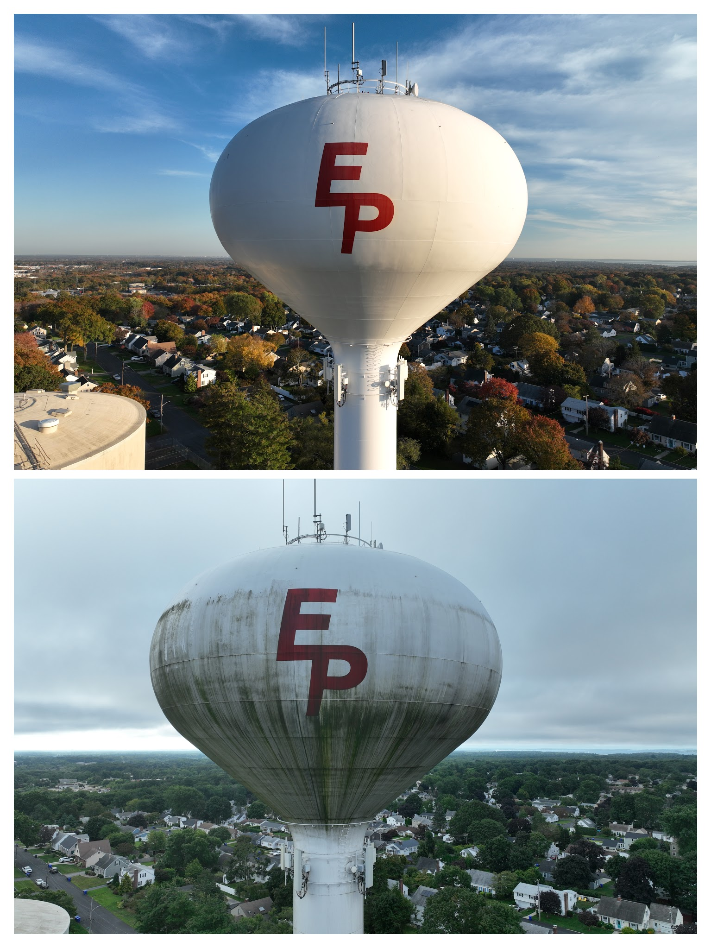
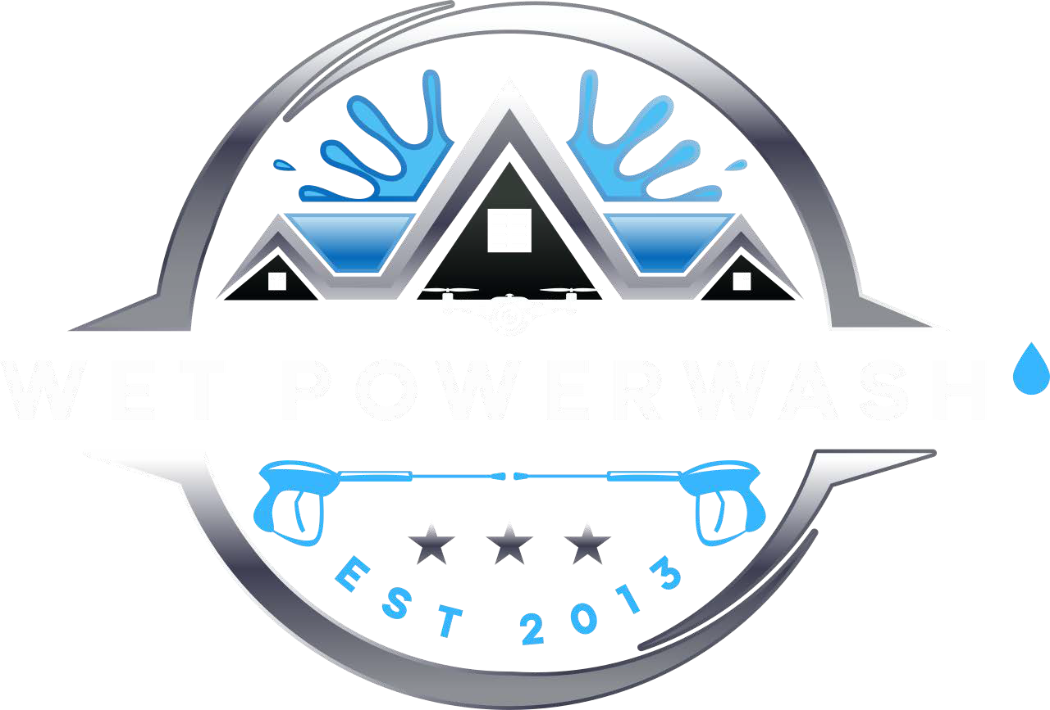
Wet Drone Advantage
Our drones combine military precision with a gentle, yet effective soft-washing process to remove dirt, grime, mold, algae, and other contaminants from surfaces without the need for high-pressure water streams.

DRONE SOFT-WASHING |  | TRADITIONAL PRESSURE-WASHING
PRECISION & REACH | Can access difficult- to-reach areas and greater heights | Limited, may not reach high or intricate spaces
SAFETY | Minimizes the need for workers to be on ladders or roofs, reducing injury risks | Involves physical labor and risks associated with climbing and working at heights
ECO- FRIENDLY | Uses eco-friendly cleaning solutions, that are less harmful to the environment | High-pressure water can lead to water wastage and potential chemical runoff
SURFACE PRESEVATION | Gentle on surfaces, preventing damage like erosion or etching | Can be abrasive, might damage delicate surfaces, leading to costly repairs
CLEANING Prevents regrowth due  EFFECTIVENESS to use of specialized  eco-friendly detergents |  | May not prevent regrowth as effectively without use of chemicals
EFFICIENCY | Faster and more efficient for large and complex structures | Slower for large projects due to manual maneuvering
COST EFFICIENCY | Reduces labor costs and potential damage expenses, making it cost-effective | Labor-intensive and involve repair costs for damaged surfaces
NOISE & Drones are quiet,  DISTRUPTION minimizing disruptions |  | Can be noisy, causing disturbances

Why Choose
Wet Drone Solutions?
Experienced Team: Our skilled professionals bring years of expertise to every project. All drone operators are federally licensed
by the FAA.
Advanced Equipment: We use state-of-the-art drones to deliver precision cleaning.
Safety First: Our methods are environmentally friendly and safe for all surfaces.
Customer Satisfaction: We’re not satisfied until you are thrilled with the results.

Discover the Wet Drone Solutions
Difference today!

Contact Our Helpful Crew Phone 401-495-4500
Email greg@wetpowerwash.com

Discover the future of cleaning with Drone-Powered Solutions!
Introducing Wet Drone Solutions – Elevating Your Cleaning Experience

Unmatched Precision Environmentally Friendly Safe and Efficient Competitive Pricing

Contact us today and soar to new heights in clean!
401-495-4500 greg@wetpowerwash.com

Our Advantage
At Wet Drone Solutions, we take pride in revolutionizing exterior cleaning. We’re not just another power-washing service – we’re your pioneering partner in maintaining a pristine appearance of your property. With cutting- edge technology, and a commitment to excellence, we redefine what clean means.

Our Services
Residential Cleaning
Enhance your home’s curb appeal with our gentle, yet effective exterior cleaning services. Say goodbye to grime, mold, and dirt.
Commercial Cleaning
Keep your business looking at its best with our commercial cleaning solutions. Impress clients

How Our Process Works
- Assessment: We conduct a thorough inspection of your property to understand your cleaning needs.
- Planning: Our team devises a customized cleaning plan tailored to your specific requirements.
- Execution: Our state-of-the-art drones take

Unparalleled Efficiency
  - Precision-cleaning for even the most hard-to-reach areas
and surfaces
  - Reduces project timelines, saving you time and money

Eco-Friendly Cleaning
Comprehensive Services
  - Commercial buildings, residential properties, and more
    - Graffiti removal, moss and mold control, risk reduction
of infestation

Enhanced Safety
and maintain a professional image.
High-Rise Buildings
Reach new heights in cleanliness with our high-rise cleaning services. We specialize in hard-to-reach areas.
Industrial Cleaning
From warehouses to factories, we tackle tough industrial cleaning challenges with ease.
flight, delivering precise and efficient cleaning. (When Applicable)
- Quality Assurance: We ensure the job is done to perfection, leaving your property spotless.
- Client Satisfaction: Your satisfaction is our top priority. We’re not finished until you’re thrilled with the results.

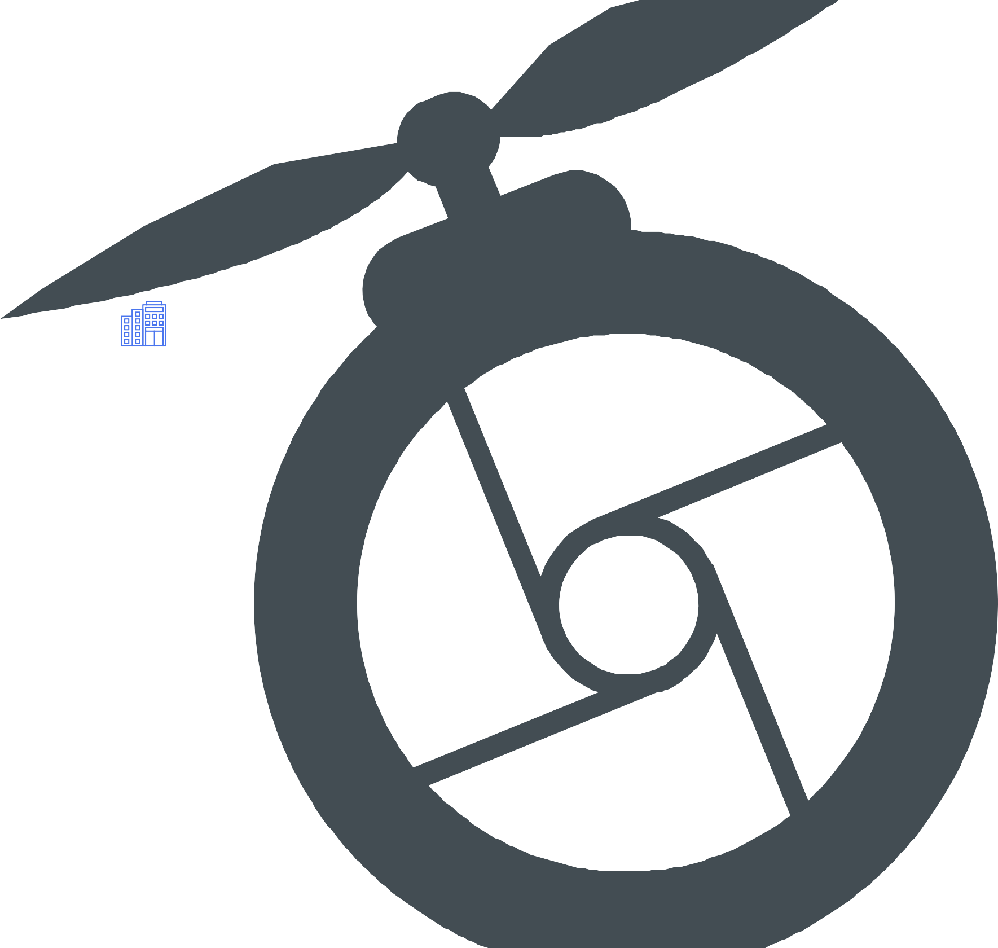

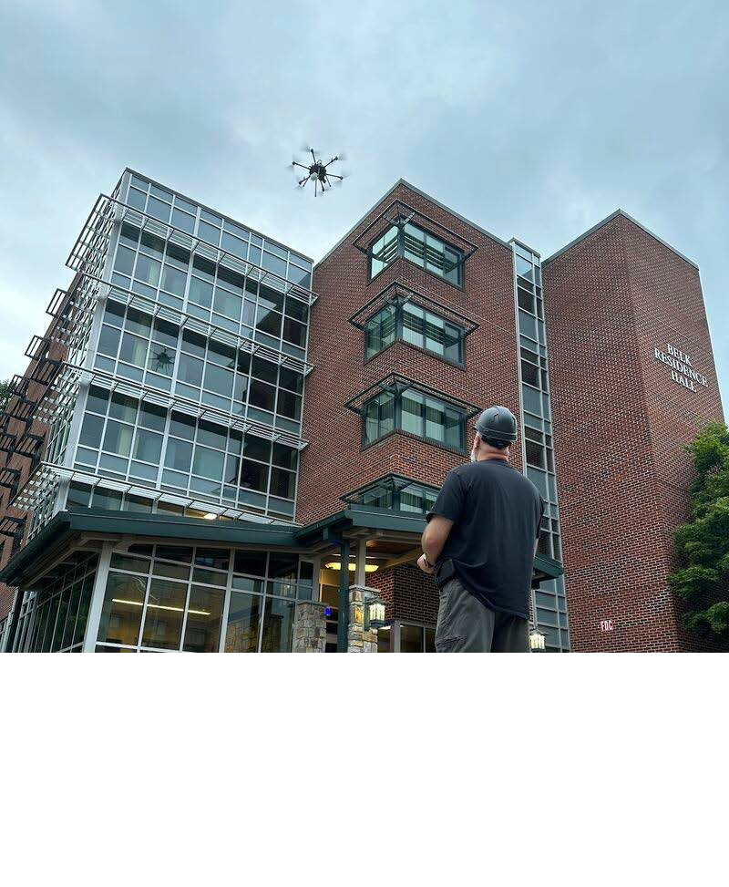

  - Biodegradable, ecologically responsible cleaning solutions
    - Uses fewer resources and minimizes water wastage

Boost Property Value
      - Enhances property’s curb appeal
    - Prevents costly repairs in the long run
- Eliminates the need for risky climbs or bulky and costly scaffolding
  - Minimizes human error and human accidents

Cost Savings
    - Reduced dependency on manual labor
    - Fewer equipment needs, minimizing operational costs
Building Exteriors Window Cleaning Skylight Cleaning Roofs & Gutters Solar Panels
Shingle Roof Cleaning Spanish Style (Clay) Roof Cleaning
2D and 3D Aerial Asset Modeling
Creation of Asset Digital Twins
Infrared Inspections
- To ensure your Solar Panels are Working Properly
- Energy Audits – We identify areas of heat loss/insulation deficiencies
Photogrammetry & Ortho mosaic Scanning Jobsite Progress Monitoring
Aerial Property Inspection

